**BGP for IPv6**

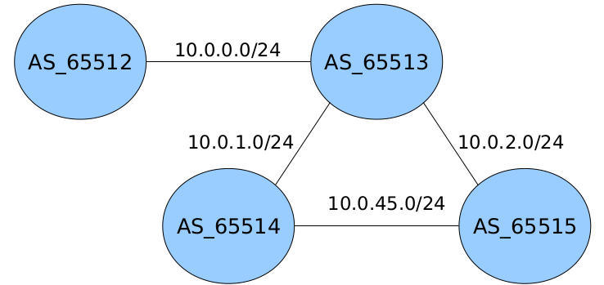

**Enunciado**

* Reutiliza la arquitectura BGP anterior para dar soporte a IPv6.
* Prefijos anunciados:
  + AS_65512 → 2001:db8:12::/52, 2001:db8:12:1000::/52, 2001:db8:12:2000::/52
  + AS_65513 → 2001:db8:13:1::/64, 2001:db8:13:2::/64
  + AS_65514 → 2001:db8:14::/64, 2001:db8:14:2::/64, 2001:db8:14:3::/64
  + AS_65515 → 2001:db8:15::/64, 2001:db8:15:1::/64, 2001:db8:15:2::/64

**Solución**

1º) UML1

vtysh

configure terminal

router bgp 65512

address-family ipv6

neighbor 10.0.0.3 activate

network 2001:db8:12::/52

network 2001:db8:12:1000::/52

network 2001:db8:12:2000::/52

exit-address-family

do write

2º) UML2

vtysh

configure terminal

router bgp 65513

address-family ipv6

neighbor 10.0.2.5 activate

neighbor 10.0.1.4 activate

neighbor 10.0.0.2 activate

network 2001:db8:13:1::/64

network 2001:db8:13:2::/64

exit-address-family

do write

3º) UML3

vtysh

configure terminal

router bgp 65514

address-family ipv6

neighbor 10.0.1.3 activate

neighbor 10.0.45.5 activate

network 2001:db8:14::/64

network 2001:db8:14:2::/64

network 2001:db8:14:3::/64

exit-address-family

do write

4º) UML4

vtysh

configure terminal

router bgp 65515

address-family ipv6

neighbor 10.0.2.3 activate

neighbor 10.0.45.4 activate

network 2001:db8:15::/64

network 2001:db8:15:1::/64

network 2001:db8:15:2::/64

exit-address-family

do write

// ******************************** TOPOLOGÍA DE LA RED ****************************************

show ipv6 bgp

show ipv6 route bgp